IBM Assignment

1. **Python Calculator**

def add():

a = int(input("Enter num 1 :"))

b = int(input("Enter num 2 :"))

return a + b

def sub():

a = int(input("Enter num 1 :"))

b = int(input("Enter num 2 :"))

return a - b

def mul():

a = int(input("Enter num 1 :"))

b = int(input("Enter num 2 :"))

return a * b

def div():

a = int(input("Enter num 1 :"))

b = int(input("Enter num 2 :"))

if(b == 0):

return ("Divisor cannot be zero")

return a / b

if __name__ == "__main__":

while(True):

print("Enter your Choice:")

print("1) Addition\n2) Subtraction\n3)Multiplication\n4) Division")

choice = int(input())

if(choice == 1):

print(add())

elif(choice == 2):

print(sub())

elif(choice == 3):

print(mul())

elif(choice == 4):

print(div())

else:

print("Enter a valid choice")

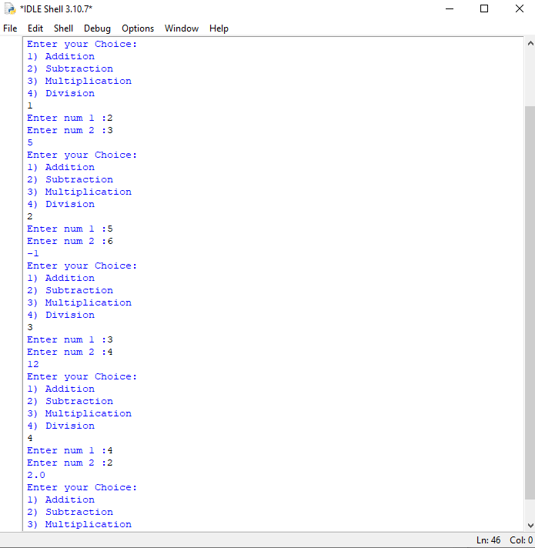

**2)Python List**

myList = [1,2,3,4,5,6,7,8,9]

print("The original List")

print(myList)

print("Inserting an element in the List at position 3")

myList.insert(3, 100)

print(myList)

print("Remove an element in the List")

myList.remove(1)

print(myList)

print("Appending an element in the List")

myList.append(10)

print(myList)

print("Pop an element in the List")

myList.pop(2)

print(myList)

print("Reverse an element in the List")

myList.reverse()

print(myList)

print("sort an element in the List")

myList.sort()

print(myList)

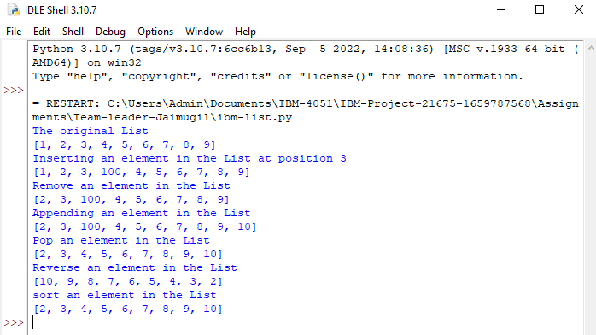

**3)Python Concatenation**

s1=input('Enter the first string : ')

s2=input('Ente the second string ')

s3=s1+s2

print('The concatenated string:'+s3)

print('sliced string :'+s3[1:len(s3):2])

print('reversing the string :'+s3[::-1])

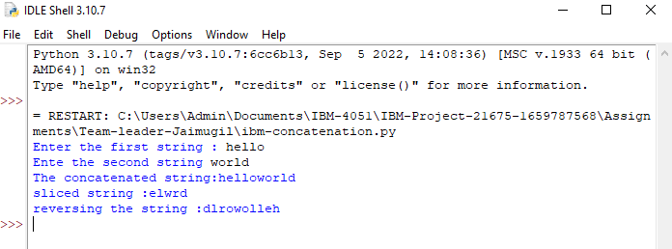

**4)Why is python a popular programming language ?**

**Python** is the main coding language for around 80% of developers. The presence of extensive libraries in Python facilitates artificial intelligence, data science, and machine learning processes. Currently, Python is trending and can be regarded as the king of programming languages

**5)What are the other framworks that can be used with python?**

1. Django
2. Pyramid,
3. TurboGears
4. Web2py
5. CherryPy
6. Flask
7. Sanic

**6)Fullform of WSGI?**

**WSGI stands for "Web Server Gateway Interface"**. It is used to forward requests from a web server (such as Apache or NGINX) to a backend Python web application or framework.